Joseph McCarthy and McCarthyism
Read Page 180 on McCarthyism and answer the following questions:

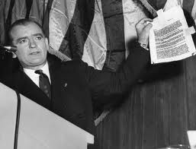

- When did Americans first fear communism?

- Why was fear of communism called the “Red Scare?”

- Who was Joseph McCarthy?

- What part of the US society did Joe McCarthy say communists had infiltrated?

- Why were critics afraid to criticize Senator Joe McCarthy?

- What charge did Joseph McCarthy make in 1954?

- Why did the Senate finally censure or condemn Joseph McCarthy?

- What happened to McCarthy in 1954?

- What is McCarthyism?

